TUMOR DETECTION USING DIGITAL IMAGE PROCESSING



GACS-7205 The final project on Digital Image Processing to Professor Dr.Simon Liao in partial fulfilment for the degree of Master of Science



SUBMITTED BY: SRINIVAS KASTURI

(3078674)

SUBMITTED ON: 12/20/2016

E-MAIL: srinivas.kasturi99@gmail.com

**Acknowledgement**

I would like to thank my Professor, Simon Liao for the successful completion of this project. He is the most knowledgeable person I ever come across. He is my educational resource and mentor whom I can rely on anytime for my academics.

**CONTENTS:**

1. Introduction
2. TUMOR
3. Types of Tumor
   1. Benign Tumor
   2. Malignant
   3. Pre-malignant
4. MRI
5. Methodology
   1. Preprocessing
   2. Gray scale
   3. Nosie removal
   4. HPF
   5. Post processing
   6. Threshold Segmentation
   7. Watershed Segmentation
   8. Morphological Operators
6. Output/results
7. Advantages
8. Future works
9. Conclusion
10. References

**ABSTRACT:**

The part of the image that has the tumor has more intensity in that portion and assumptions are made about the radius of the tumor in the image, are the key things considered in the algorithm. Beginning with, some image enhancement and noise reduction techniques are used to enhance the image quality, followed by some morphological operations which are applied to detect the tumor in the image. The morphological operations are basically applied on some assumptions related to the size and shape of the tumor and in the end the tumor is mapped onto the original gray scale image with an intensity of 255 to make visible the tumor in the image. The algorithm has been tried on a number of different images from different angles and helps in giving the desired result with precision.

1. **INTRODUCTION:**

The purpose of our project is to identify a tumor from a given MRI scan of a brain using digital image processing techniques.

1. **TUMOR:**

Tumour is defined as the abnormal growth of the tissues. Brain tumor is an abnormal mass of tissue in which cells grow and multiply uncontrollably, seemingly unchecked by the mechanisms that control normal cells. Brain tumors can be primary or metastatic, and either malignant or benign. A metastatic brain tumor is a cancer that has spread from elsewhere in the body to the brain.

Epilepsy is a brain disorder in which clusters of nerve cells, or neurons, in the brain sometimes signal abnormally. Neurons normally generate electrochemical impulses that act on other neurons, glands, and muscles to produce human thoughts, feelings, and actions. In epilepsy, the normal pattern of neuronal activity becomes disturbed, causing strange sensations, emotions, and behaviour or sometimes convulsions, muscle spasms, and loss of consciousness.

1. **TYPES OF TUMOR:**

3.1 BENIGN TUMOR:

A benign tumor is a [tumor](http://en.wikipedia.org/wiki/Tumor) that lacks all three of the [malignant](http://en.wikipedia.org/wiki/Malignant) properties of a [cancer](http://en.wikipedia.org/wiki/Cancer). Thus, by definition, a benign tumor does not grow in an unlimited, aggressive manner, does not invade surrounding [tissues](http://en.wikipedia.org/wiki/Tissue_%28biology%29), and does not spread to non-adjacent tissues ([metastasize](http://en.wikipedia.org/wiki/Metastasize)). Common examples of benign tumors include [moles](http://en.wikipedia.org/wiki/Mole_%28skin_marking%29) and [uterine fibroids](http://en.wikipedia.org/wiki/Uterine_fibroid).

3.2 MALIGNANT:

Malignancy (from the Latin roots mal- = "bad" and -ignis = "fire") is the tendency of a medical condition, especially [tumors](http://en.wikipedia.org/wiki/Tumor), to become progressively worse and to potentially result in death. It is characterized by the properties of [anaplasia](http://en.wikipedia.org/wiki/Anaplasia), invasiveness, and [metastasis](http://en.wikipedia.org/wiki/Metastasis). Malignant is a corresponding [adjectival](http://en.wikipedia.org/wiki/Adjective) medical term used to describe a severe and progressively worsening disease. The term is most commonly used as a description of [cancer](http://en.wikipedia.org/wiki/Cancer).

3.3 PREMALIGNANT:

A precancerous condition (or premalignant condition) is a [disease](http://en.wikipedia.org/wiki/Disease), [syndrome](http://en.wikipedia.org/wiki/Syndrome), or finding that, if left untreated, may lead to [cancer](http://en.wikipedia.org/wiki/Cancer). It is a generalized state associated with a significantly increased risk of cancer.

1. **MRI:**

Magnetic resonance imaging (MRI), or nuclear magnetic resonance imaging (NMRI), is primarily a [medical imaging](http://en.wikipedia.org/wiki/Medical_imaging) technique used in [radiology](http://en.wikipedia.org/wiki/Radiology) to visualize detailed internal structure and limited function of the body. MRI provides much greater [contrast](http://en.wikipedia.org/wiki/Contrast_%28vision%29) between the different soft tissues of the body than [computed tomography](http://en.wikipedia.org/wiki/Computed_tomography) (CT) does, making it especially useful in [neurological](http://en.wikipedia.org/wiki/Neurology) (brain), [musculoskeletal](http://en.wikipedia.org/wiki/Human_musculoskeletal_system), cardiovascular, and [oncological](http://en.wikipedia.org/wiki/Oncology) (cancer) imaging. Unlike CT, MRI uses no [ionizing radiation](http://en.wikipedia.org/wiki/Ionizing_radiation). Rather, it uses a powerful [magnetic](http://en.wikipedia.org/wiki/Magnetism) field to align the [nuclear magnetization](http://en.wikipedia.org/wiki/Nuclear_magnetic_moment) of (usually) [hydrogen](http://en.wikipedia.org/wiki/Hydrogen) [atoms](http://en.wikipedia.org/wiki/Atom) of water in the body. [Radio frequency](http://en.wikipedia.org/wiki/Radio_frequency) (RF) fields are used to systematically alter the alignment of this magnetization. This causes the hydrogen nuclei to produce a rotating magnetic field detectable by the scanner. This signal can be manipulated by additional magnetic fields to build up enough information to construct an image of the body.

1. **METHODOLOGY:**

The part of the image containing the tumor normally has more intensity than the other portion and we can assume the area, shape and radius of the tumor in the image. We have used these basic conditions to detect tumor in our code and the code goes through the following steps:

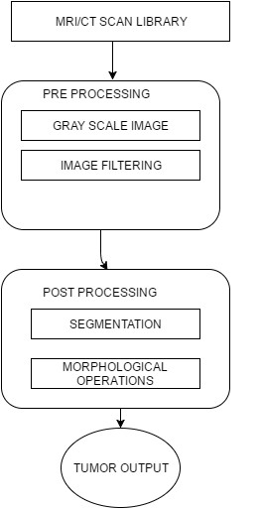

**5.1 PREPROCESSING:**

In pre-processing some basic image enhancement and noise reduction techniques are implemented. Apart from that, different ways to detect edges and carrying out segmentations have also been used. The purpose of these steps is basically, to improve the image and its quality to get more accuracy and ease in detecting the tumor. The basic steps in pre-processing are given below:

**GRAY SCALE**: Image is converted to a gray scale image in first step.

In analog practice, gray scale imaging is sometimes called "black and white," but technically this is a misnomer. In true black and white, also known as halftone, the only possible shades are pure black and pure white. The illusion of a gray shading in a halftone image is obtained by rendering the image as a grid of black dots on a white background (or vice versa), with the sizes of the individual dots determining the apparent lightness of the gray in their vicinity.

Here red (R), green (G) and blue (B) components are each represented as a number from decimal 0 to 255, or binary 00000000 to 11111111. For every pixel in a red-green-blue ( RGB ) grayscale image, R = G = B. The lightness of the gray is directly proportional to the number representing the brightness levels of the primary colors. Black is represented by R = G = B = 0 or R = G = B = 00000000, and white is represented by R = G = B = 255 or R = G = B = 11111111. Because there are 8 bit s in the binary representation of the gray level, this imaging method is called as 8-bit grayscale.

Noise is eliminated at this step..

The obtained image is then passed through a high pass filter to detect edges.

Image is given as an input to high pass filter. A high pass filter is the basis for most sharpening methods. An image is sharpened when contrast is enhanced between adjoining areas with little variation in brightness or darkness. A high pass filter tends to retain the high frequency information within an image while reducing the low frequency information. The kernel of the high pass filter is designed to increase the brightness of the center pixel relative to neighboring pixels. The kernel array usually contains a single positive value at its center, which is completely surrounded by negative values.

Then the obtained image is merged to the original image to improve it.

**5.5 PROCESSING:**

In processing the following different steps are followed:-

**5.6 THRESHOLD SEGMENTATION:**

Segmentation is done on based on a threshold, due to which whole image is converted into binary image. Basic matlab commands for thresholding are used in this case. This method is based on a clip-level (or a threshold value) to turn a gray-scale image into a binary image. The key of this method is to select the threshold value (or values when multiple-levels are selected). Several popular methods are used in industry including the maximum entropy method, Otsu's method (maximum variance), and etc. K-means clustering can also be used. More over segmentation can also be defined in the areas of the computer vision as the process of partitioning a digital image into multiple segments (sets of pixels, also known as super pixels). The goal of segmentation is to simplify and/or change the representation of an image into something that is more meaningful and easier to analyse.

The result of image segmentation is a set of segments that collectively cover the entire image, or a set of contours extracted from the image (see edge detection). Each of the pixels in a region are similar with respect to some characteristic or computed property, such as color, intensity, or texture.

**5.7 WATERSHED SEGMENTATION:**

It is the best method to segment an image for separating a tumor, but it suffers from over and under segmentation, due to which we have used it as a condition for our output. We have not used watershed segmentation on our input, rather it is only used on our output to check the accuracy of the result and we find that the correct answers are computed every time as is shown below. A drop of water falling on a topographic relief flows along a path to finally reach a local minimum. Intuitively, the watershed of a relief correspond to the limits of the adjacent catchment basins of the drops of water. In image processing, different watershed lines may be computed. In graphs, some may be defined on the nodes, on the edges, or hybrid lines on both nodes and edges. Watersheds may also be defined in the continuous domain. There are also many different algorithms to compute watersheds.

Meyer's flooding Watershed Algorithm:

The algorithm works on a gray scale image. During the successive flooding of the grey value relief, watersheds with adjacent catchment basins are constructed. This flooding process is performed on the gradient image, i.e. the basins should emerge along the edges.

**5.8 MORPHOLOGICAL OPERATORS:**

After the conversion to the binary form some Morphological operations are applied to the image. Image processing is a collection of nonlinear operations related to the shape or morphology of features in an image.

Main objective of the operations is to show only that part of the image which has the tumor that is the part of the image having more intensity and more area then that specified in the strel command. Operations rely only on the relative ordering of pixel values, not on their numerical values, and therefore are especially suited to the processing of binary images. Morphological operations can also be applied to greyscale images such that their light transfer functions are unknown and therefore their absolute pixel values are of no or minor interest.

The basic commands used in this step are strel, imerode and imdilate.

Imerode():

It is used to erode an image.

Imdilate():

It is used to dilate an image.

1. **OUTPUTS/RESULTS:**

These figures shows the images as an output. i.e grayscale image, high pass filtered image , threshold image, watershed segmented image, Finally input image and extracted tumour from MRI image. For this purpose real time patient data is taken for analysis.As tumour in MRI image have an intensity more than that of its background so it become very easy locate it and extract it from a MRI image

We have mapped the resultant tumor image onto the original grayscale image for presentation purposes.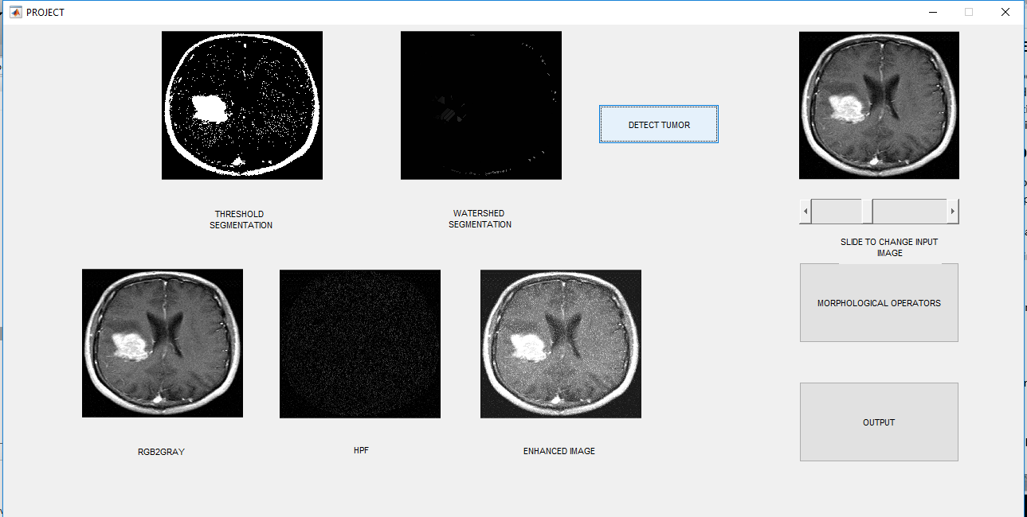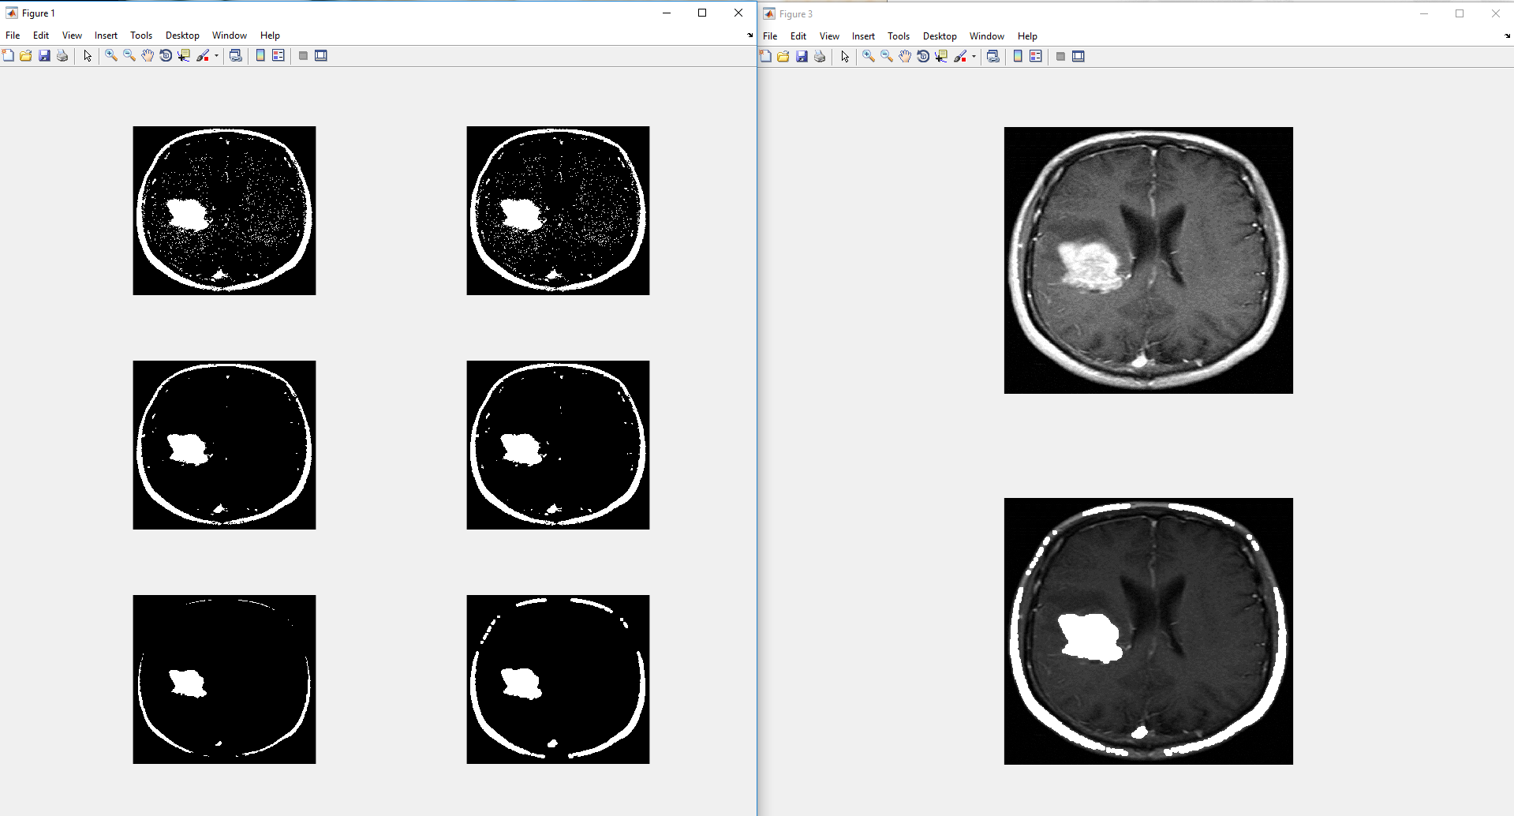

TUMOR

**OTHER RESULTS:**

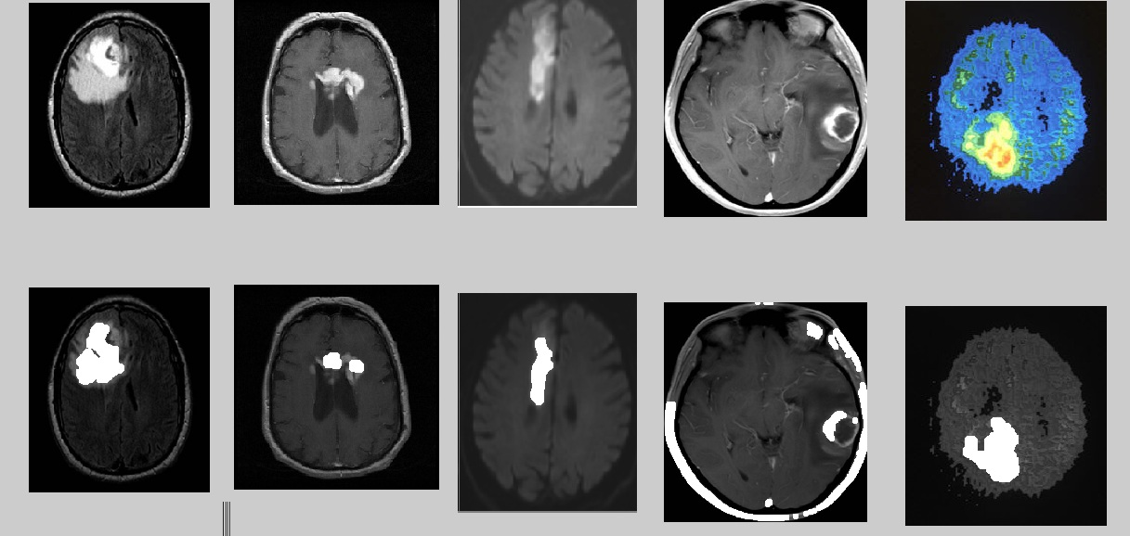

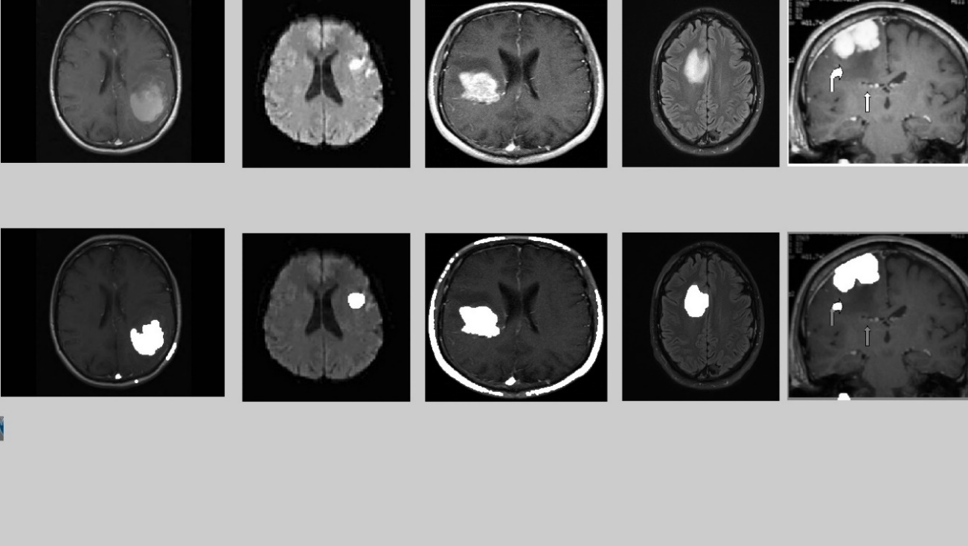

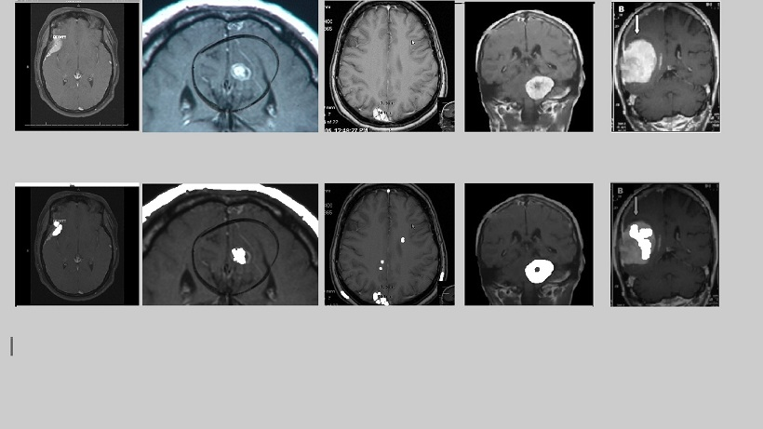

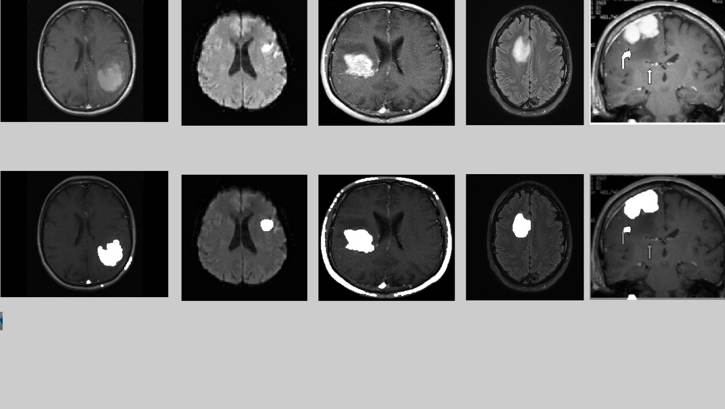

1. **ADVANTAGES:**

* Uses region-based left-right symmetry, rather than point-wise symmetry
* Uses single MR image
* No training data required
* No image registration needed

1. **FUTURE WORK:**

There is a significant scope to extend this program so as to classify the tumor according to its type. Also tumour growth can be analysed by plotting graphs which can be obtained by studying sequential images of tumour affected patient.

1. **CONCLUSION:**

In this project work we proposed the approach for Brain tumor detection & identification. We proposed detection and identification of brain tumor through Magnetic Resonance (DICOM) Image using gray-scale imaging, noise removal, Threshold segmentation and Watershed Segmentation. The proposed image processing algorithm is based on a modified Thresholding algorithm with morphological operators and implemented using MATLAB Software. However, simulation results using this algorithm showed its ability to accurately detect and identify the contour of the tumor, its computational time and accuracy were much less than other algorithms. For future we enhance our result using other Algorithm and calculate more parameters.

**11. REFERENCES:**

[1] W. Gonzalez, “Digital Image Processing”, 2nd ed. Prentice Hall, Year of Publication 2008, Page no 378.

[2] S. Murugavalli, V. Rajamani, “A high speed parallel fuzzy c-mean algorithm for brain tumour segmentation”,” BIME Journal”, Vol. no: 06, Issue (1), Dec., 2006

[3] Mohamed Lamine Toure, “Advanced Algorithm for Brain Segmentation using Fuzzy to Localize Cancer and Epilepsy Region”, International Conference on Electronics and Information Engineering (ICEIE 2010), Vol. no 2.

[4] Dr.G.Padmavathi, Mr.M.Muthukumar and Mr. Suresh Kumar Thakur, “Non linear Image segmentation using fuzzy c means clustering method with thresholding for underwater images”, IJCSI International Journal of Computer Science Issues, Vol. 7, Issue 3, No 9, May 2010

[5] Matei Mancas, Bernard Gosselin, Benoît macq, “Segmentation Using a Region Growing Thresholding” [6] T .Logeswari and M.Karnan “An improved implementation of brain tumor detection using segmentation based on soft computing” Journal of Cancer Research and Experimental Oncology Vol. 2(1) pp. 006-014, March, 2010